Project 2- Data management.

1. Loaded the CSV data into table temp_project2_csv_load

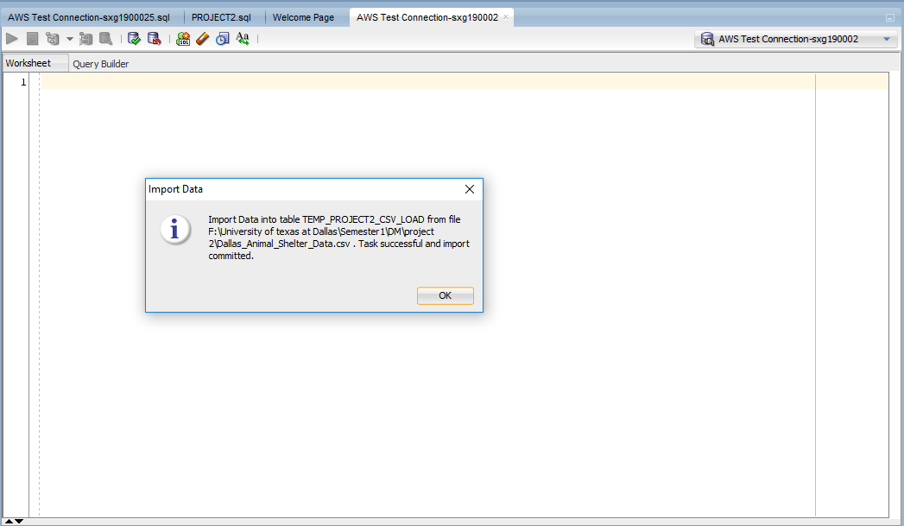

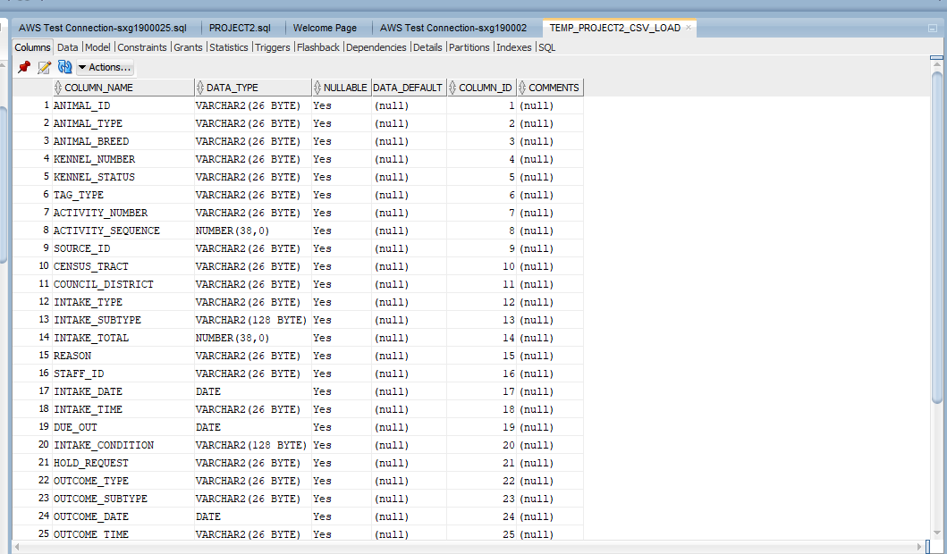

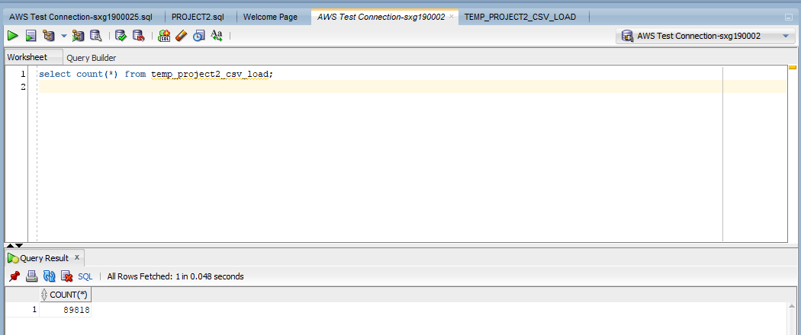

1. Create table project2_data_load

CREATE TABLE Project2_Data_Load

AS SELECT * FROM TEMP_PROJECT2_CSV_LOAD

WHERE intake_date <'01/11/2019';

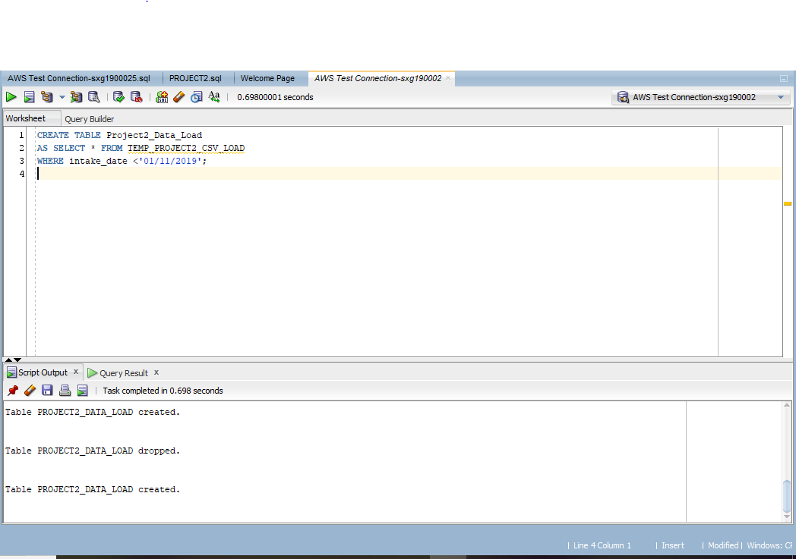

SELECT MIN(Intake_Date),MAX(Intake_Date) FROM Project2_Data_Load;

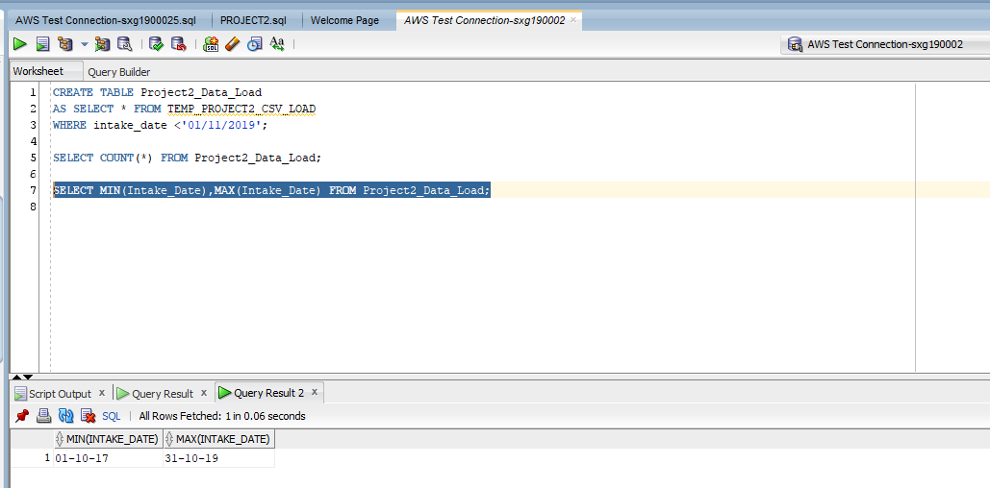

SELECT COUNT(*) FROM Project2_Data_Load;

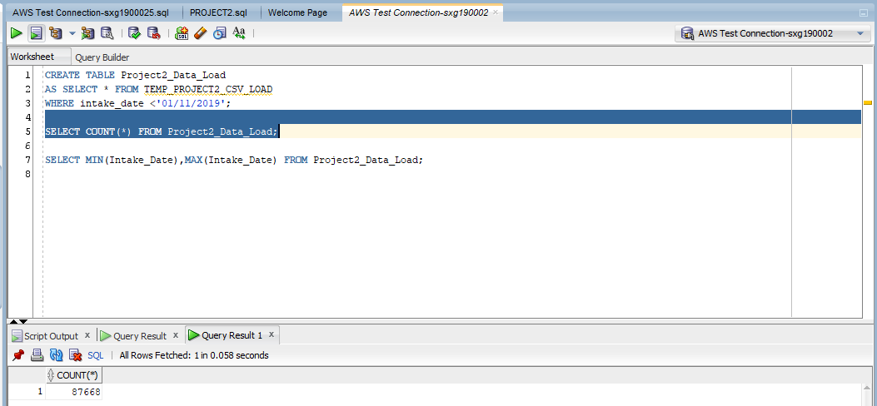

Checking duplicate in animal_ids

SELECT COUNT(1)

FROM

(

SELECT ANIMAL_ID,COUNT(1)

FROM Project2_Data_Load

GROUP BY ANIMAL_ID

HAVING count(1)>1

);

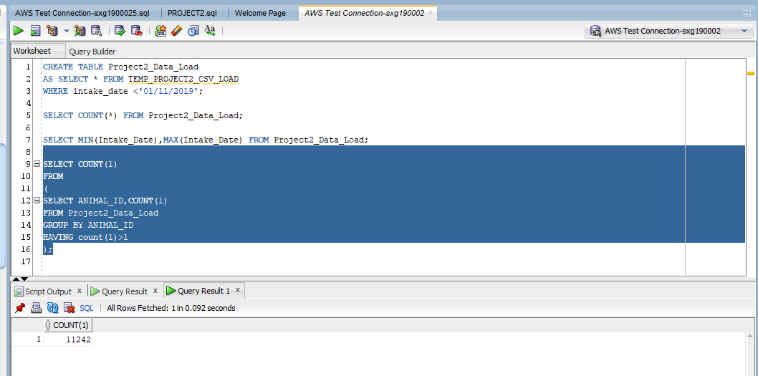

TABLES CREATED:

**CREATE TABLE Animal**

**(**

**AnimaL_ID VARCHAR2(26) PRIMARY KEY NOT NULL,**

**Animal_Type VARCHAR2(26),**

**Animal_Breed VARCHAR2(26)**

**);**

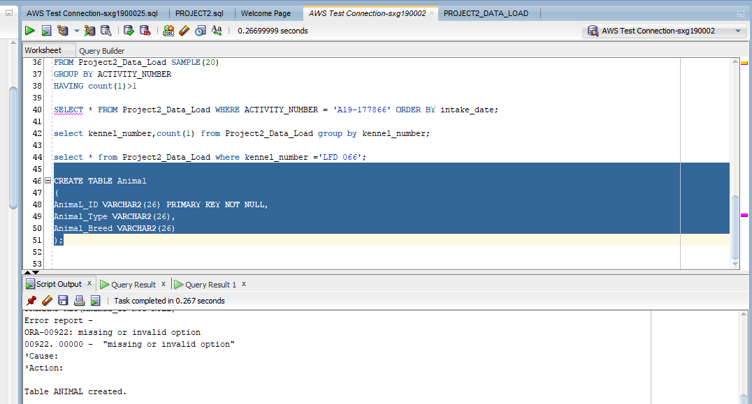

**INSERT INTO Animal**

**SELECT Animal_ID,Animal_Type,Animal_Breed**

**FROM Project2_Data_Load**

**GROUP BY Animal_ID,Animal_Type,Animal_Breed;**

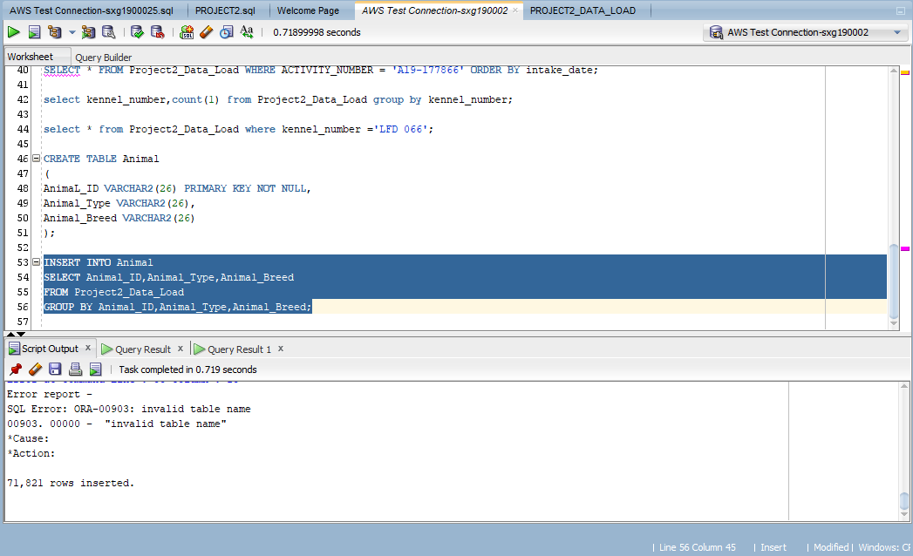

Intake Table

create sequence intake_id increment by 1 ;

CREATE TABLE Intake AS

SELECT Intake_Type FROM Project2_Data_Load

GROUP BY Intake_Type;

ALTER TABLE Intake ADD Intake_Type_ID INT;

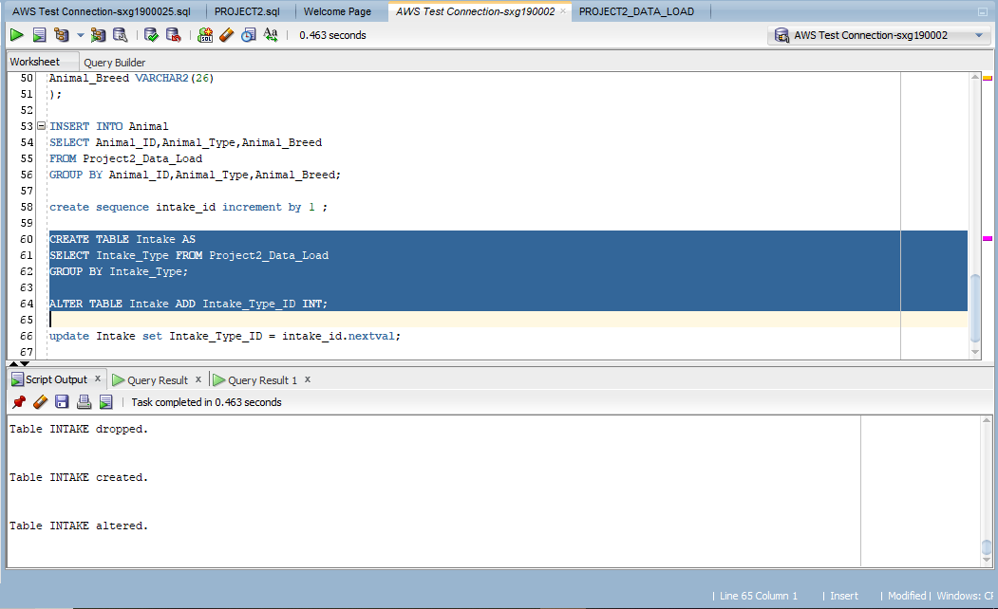

update Intake set Intake_Type_ID = intake_id.nextval;

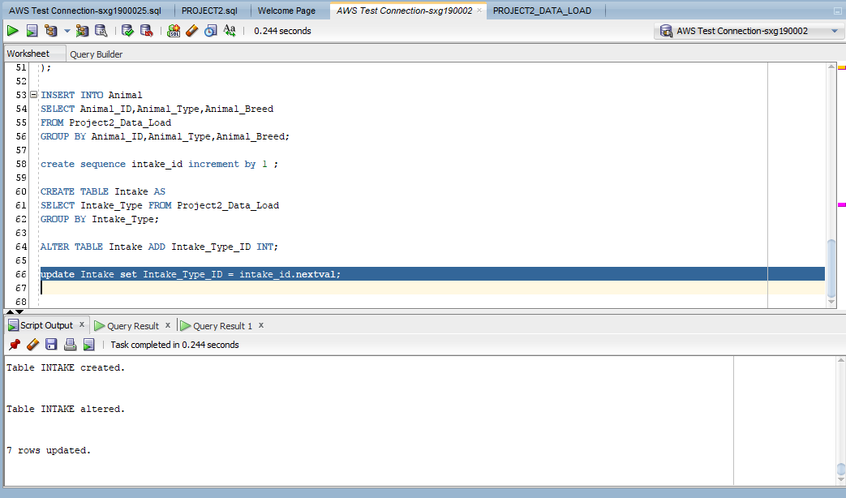

select * from Intake;

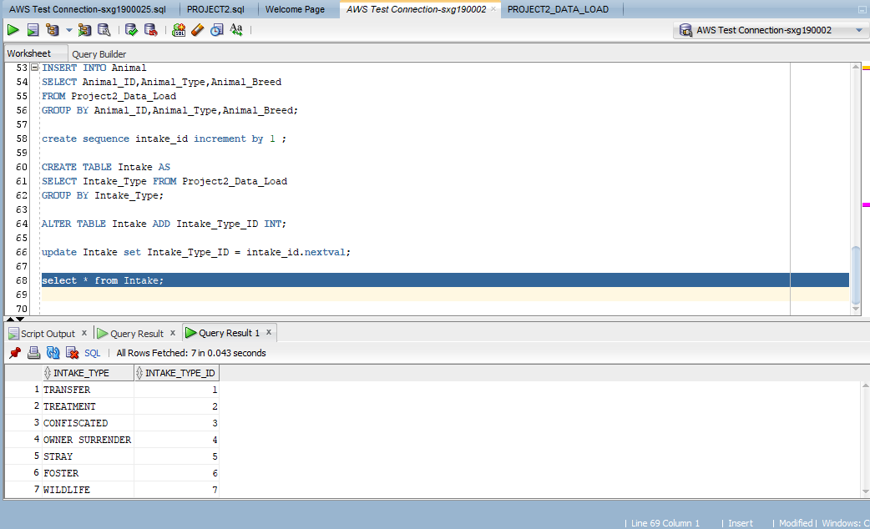

CREATE TABLE Project2_Data_Load

AS SELECT * FROM TEMP_PROJECT2_CSV_LOAD

WHERE intake_date <'01/11/2019';

SELECT COUNT(*) FROM Project2_Data_Load;

SELECT * FROM Project2_Data_Load;

SELECT MIN(Intake_Date),MAX(Intake_Date) FROM Project2_Data_Load;

SELECT COUNT(1)

FROM

(

SELECT ANIMAL_ID,COUNT(1)

FROM Project2_Data_Load

GROUP BY ANIMAL_ID

HAVING count(1)>1

);

SELECT ANIMAL_ID,COUNT(1)

FROM Project2_Data_Load SAMPLE(20)

GROUP BY ANIMAL_ID

HAVING count(1)>1;

SELECT * FROM Project2_Data_Load WHERE Animal_ID = 'A1023489' ORDER BY intake_date;

SELECT COUNT(1)

FROM

(

SELECT ACTIVITY_NUMBER,COUNT(1)

FROM Project2_Data_Load

GROUP BY ACTIVITY_NUMBER

HAVING count(1)>1

);

SELECT ACTIVITY_NUMBER,COUNT(1)

FROM Project2_Data_Load SAMPLE(20)

GROUP BY ACTIVITY_NUMBER

HAVING count(1)>1

SELECT * FROM Project2_Data_Load WHERE ACTIVITY_NUMBER = 'A19-177866' ORDER BY intake_date;

select kennel_number,count(1) from Project2_Data_Load group by kennel_number;

select * from Project2_Data_Load where kennel_number ='LFD 066';

CREATE TABLE Animal

(

AnimaL_ID VARCHAR2(26) PRIMARY KEY NOT NULL,

Animal_Type VARCHAR2(26),

Animal_Breed VARCHAR2(26)

);

INSERT INTO Animal

SELECT Animal_ID,Animal_Type,Animal_Breed

FROM Project2_Data_Load

GROUP BY Animal_ID,Animal_Type,Animal_Breed;

SELECT * FROM Animal;

create sequence intake_id increment by 1 ;

CREATE TABLE Intake AS

SELECT Intake_Type FROM Project2_Data_Load

GROUP BY Intake_Type;

ALTER TABLE Intake ADD Intake_Type_ID INT;

update Intake set Intake_Type_ID = intake_id.nextval;

select * from Intake;

CREATE TABLE